Garrett’s Workshop

“ROM01” Upgrade for Apple IIgs

User’s Guide

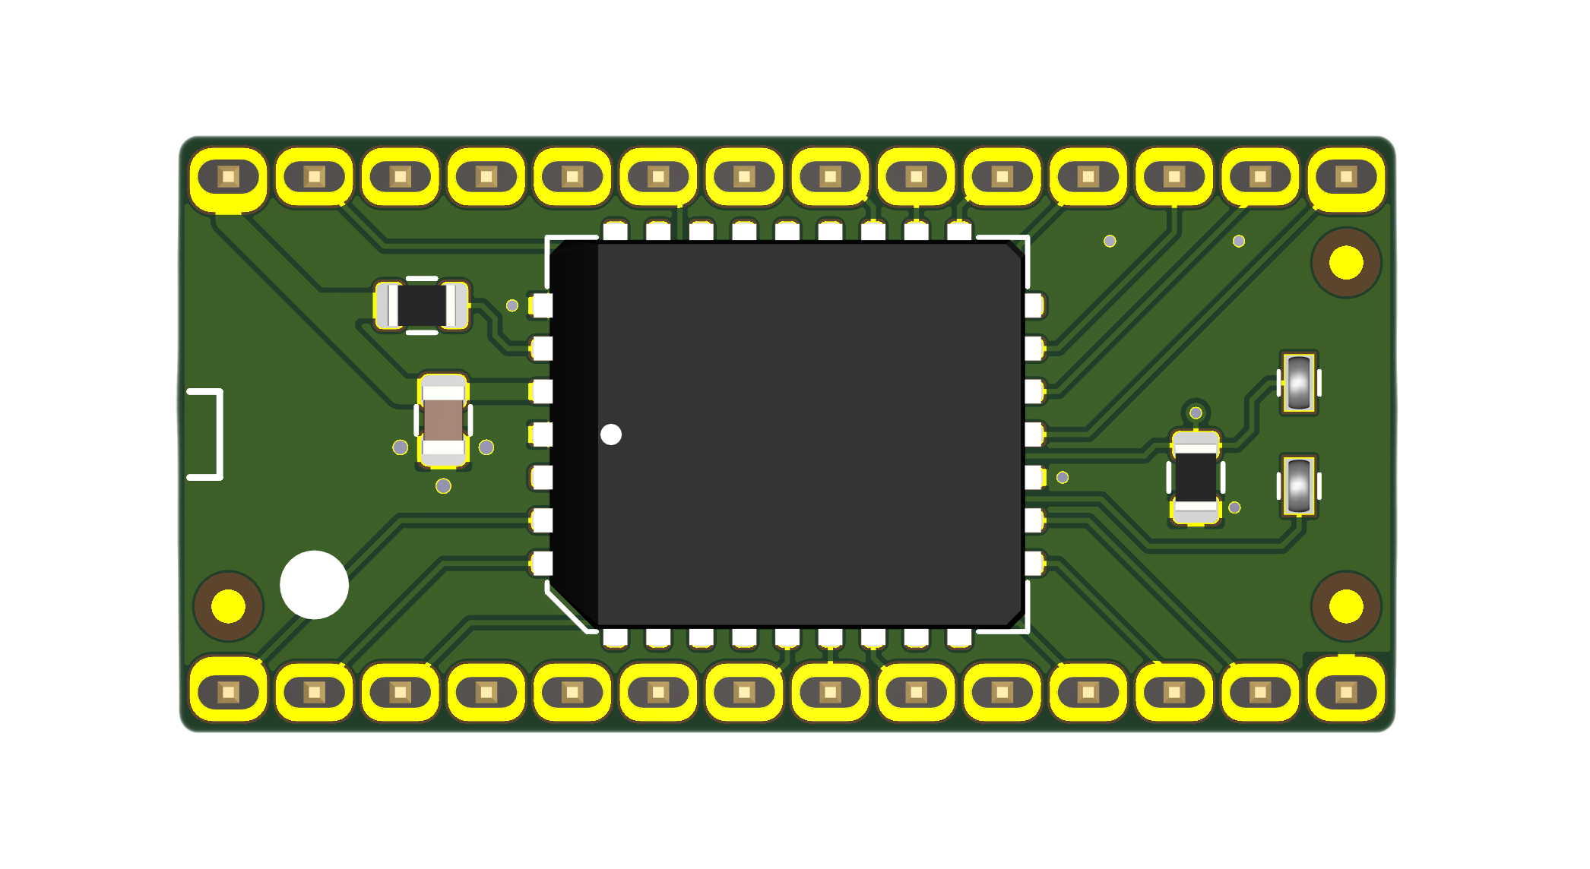

Overview
This product upgrades an Apple IIgs system from ROM version 0 to ROM version 1. It can also be used to replace a broken ROM chip on a ROM1 system.

Installation
To install the ROM upgrade, remove the existing ROM chip from your Apple IIgs system, then install the replacement chip in the same socket. Be sure to install the ROM upgrade in the correct orientation. “Pin 1” markings on the ROM upgrade and Apple IIgs motherboard indicate the correct orientation for the ROM upgrade in the socket. Shown below is a picture of the ROM installed in the correct orientation:
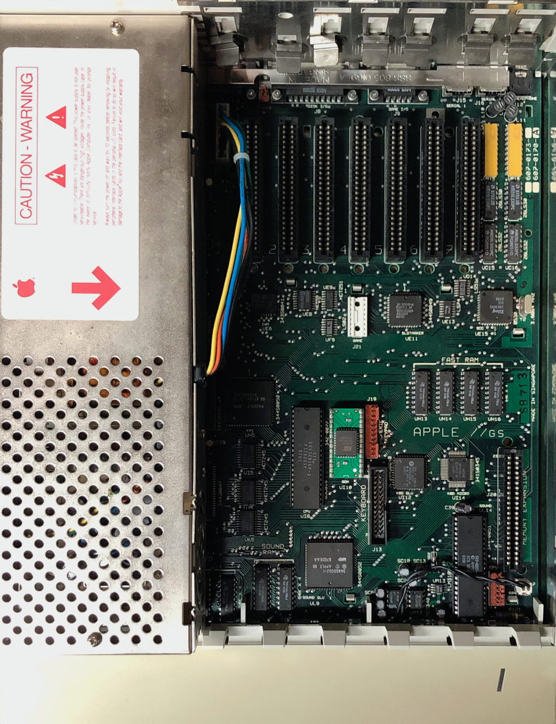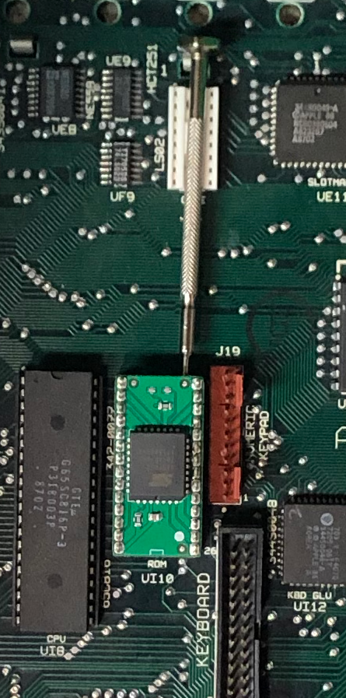
To remove a ROM from the ROM socket, we recommend gently wiggling a screwdriver underneath the chip, alternating between the top and bottom, until the ROM can be gently removed.

